Work Gallery

On stage, on screen and on location
From fitness conventions to celebrity collaborations, Faye has brought her signature energy to some of the biggest names in fitness and wellness. Explore the gallery to see Faye’s style in action, then get in touch to bring it to your next event, brand or platform.

At the bottom:
Love what you see? Book Faye for your next event, campaign or collaboration.

Videos:

RETREATS
Mind Fit Retreat Zanzibar showreel https://youtu.be/OleqgOAs3uQ?si=EK1V_DXvmnRYC9hc

F.I.T Trip Bulgaria The Grand Tour
https://youtu.be/SzG1K4JmaGE?si=wleb0RGtQEg5ASi0

F.I.T Trip Bulgaria Testimonials
https://youtube.com/shorts/LvKvW0APzv8?si=LTgar3-4RudSGpR-

PRESENTING AND HOSTING
Kelly Holmes Athena Effect Hosting
https://youtube.com/shorts/YoM_-nFKz-I?si=LFyXk8Jg6Bz5R4mk

Ladies Who Launch Rochelle Humes Event
https://youtube.com/shorts/v0HtWzvNiH0?si=kgXQ6SmhR83glXph

Kelly Holmes Athena Effect Hosting
https://youtube.com/shorts/YoM_-nFKz-I?si=LFyXk8Jg6Bz5R4mk

Panel talk at Tab London
https://youtube.com/shorts/L9uYzPHlbyU?si=vw6tW5YyiA6ilReW

TEACHING
Johnson Digital Studios Dance Workout
https://youtu.be/dPTK7uC46hI?si=RCdArWP4VAK2Eeu7

F.I.T Jam at Hackney Moves
https://youtu.be/n97Fw5VQXnw?si=jLjT0KOwhId-OBIZ

Band Workout for Third Space
https://youtube.com/shorts/-q9MY6kn2ys?si=v5lAjHLDPxjvuMEx

Over 60’s F.I.T Jam at Platinum Performing Arts
https://youtube.com/shorts/u-OBtEsEGHE?si=u7i0mMxnTCskS46z

F.I.T Combat
https://youtu.be/XxFc2PHllJE?si=lQeZUm4yCkt1kygs

Boot Camp programme
https://youtu.be/d4PvIzlun5c?si=gvjNBVwVNZJ-0jWo

F.I.T Jam Masterclass
https://youtu.be/HrLC6stu2yU?si=Xp1ccNyWvDNGY9Ez

COAHCHING
F.I.T Academy Instructors Testimonials
https://youtube.com/shorts/Hx0JR00cETY?si=-ZdQeszctE4asLXp

EVENTS

Mind Fit Empowerment Day
https://youtube.com/shorts/qMGsUgqC63c?si=OKWHSbL4oNuAay-Z

Ladies Day
https://youtu.be/bkr7InH22gM?si=r9AICkaYUHP4RxIV

F.I.T Jam at Hackney Moves
https://youtu.be/n97Fw5VQXnw?si=jLjT0KOwhId-OBIZ

F.I.T Jam Canary Wharf
https://youtu.be/qeg6hw3_keg?si=qcHMnkgFxAZW4jgR

F.I.T Jam at Move It Convention
https://youtu.be/D8My29BkuJA?si=mVMTZbBYPSgTBSDn

Bodybuilding

Hercules Olympia
https://youtu.be/V_4C4wr9mk0?si=yjcBuqkFi9CkPofl

WBFF comp prep at Reebok Sports Club
https://youtu.be/MJVw8os9Q_Y?si=Oqm6iUVxHCrfHU7G
Podcasts

The Gym Forum
https://www.youtube.com/watch?v=ZnOm7iRlp60&feature=youtu.be

Wellbeing Podcast Dubai
https://youtube.com/shorts/0R2YXebKF0g?feature=share

PICTURE GALLERY

Retreats
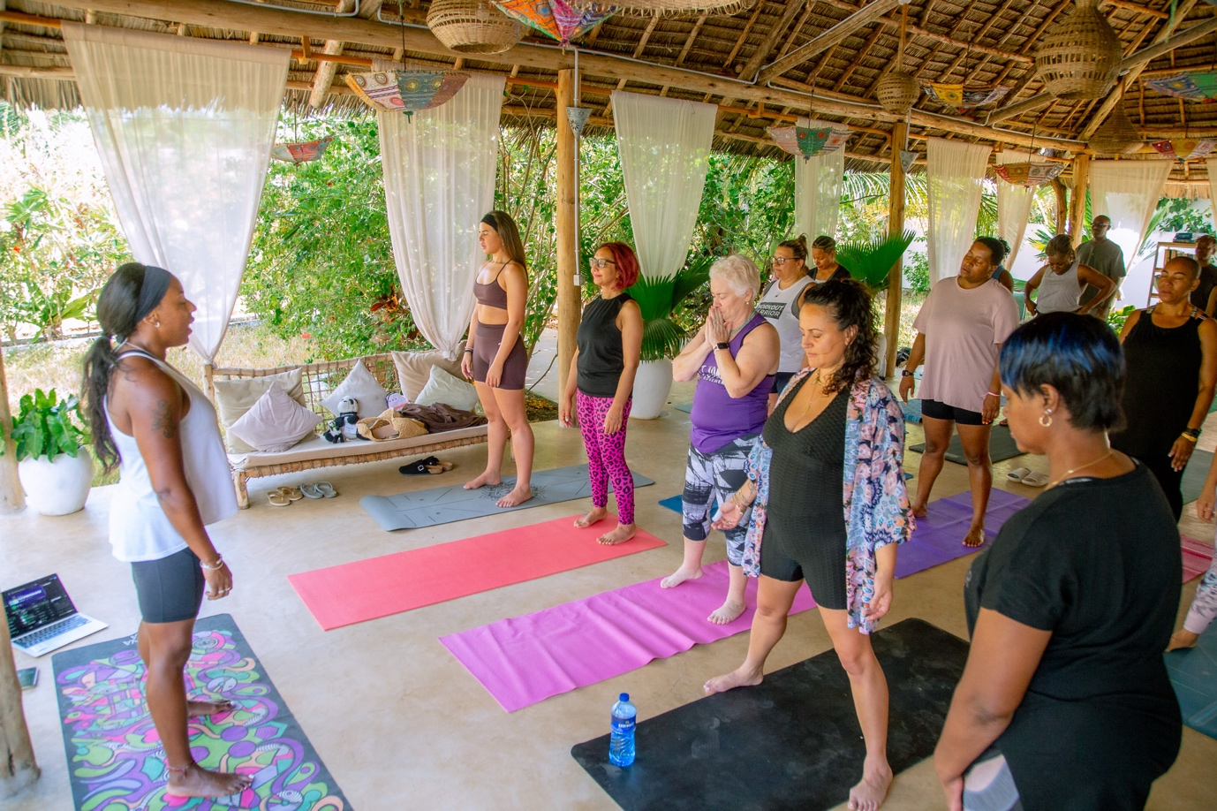
HOSTING
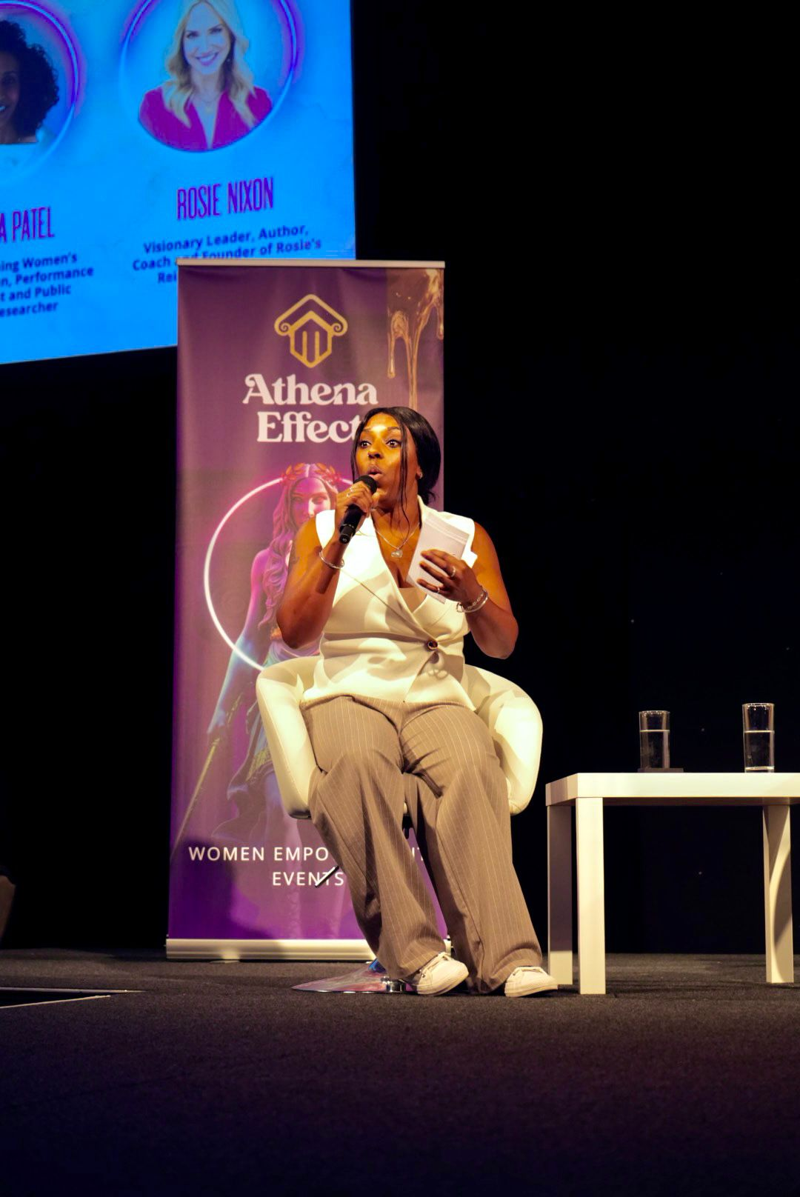
TEACHING
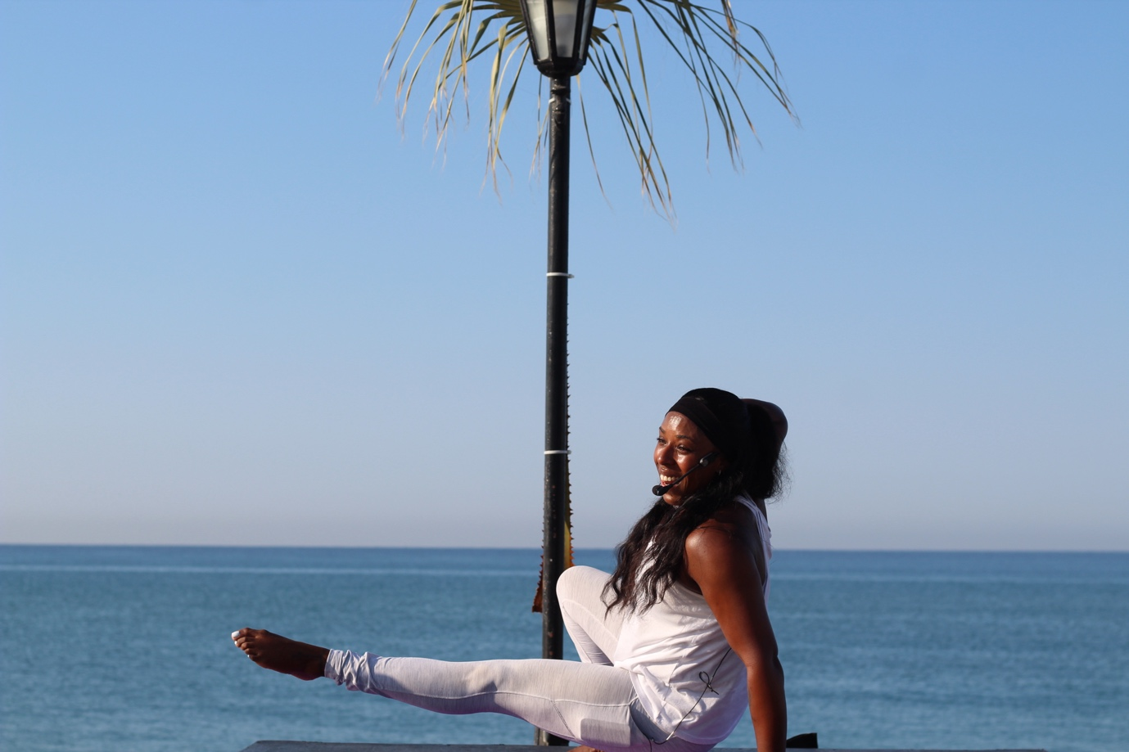
COACHING
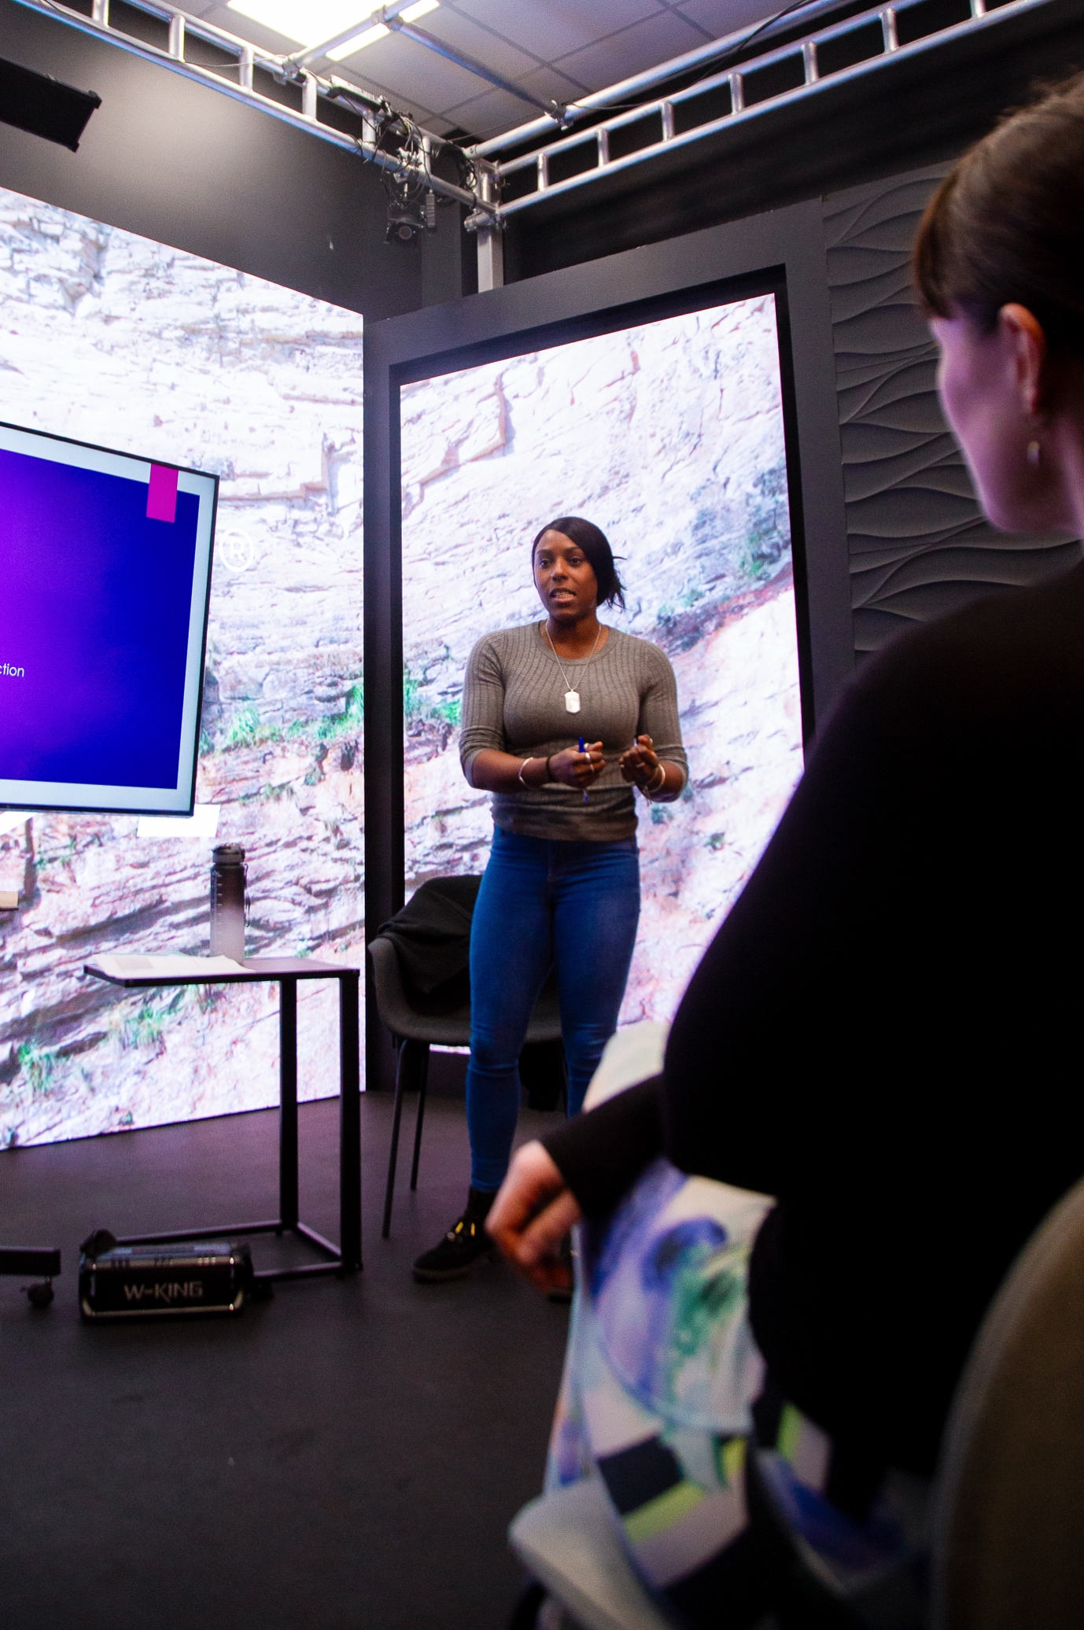
EVENTS
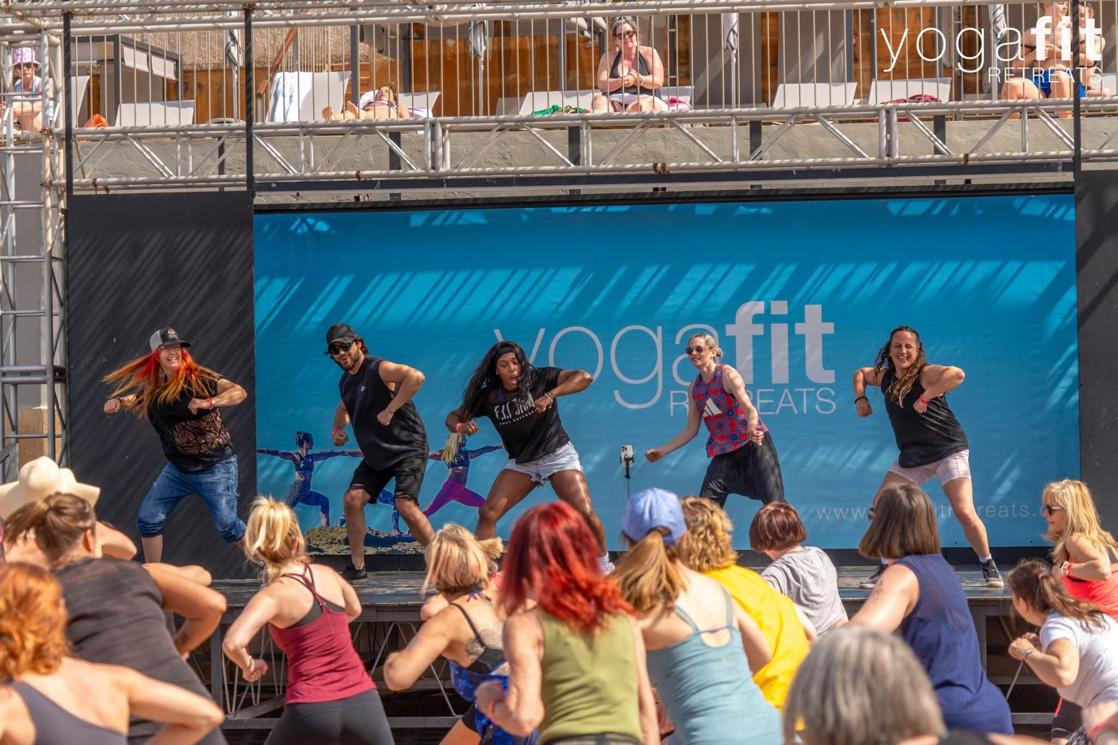
INSTRUCTIONS FROM CLAUDE:
Logo strip Put a single row of client and press logos under the summary, all in white or one colour on a dark background. Matching the logos makes them look premium instead of busy, and it echoes the Clients & Partnerships slide in your deck. Keep it to 8–12 logos and end with “and more.”

Video gallery, grouped by what you’re hired for
Use 3–4 labelled rows or tabs so a visitor finds what’s relevant to them:
- Speaking & Hosting: Kelly Holmes Athenea Effect, Rochelle Humes Ladies Who Launch, the TAB London panel
- Fitness Presenting: Third Space The Method class, F.I.T Jam with Davina, conventions and masterclasses
- Experiences: F.I.T Trip Bulgaria testimonials, Mind Fit retreat clips
Put a 30–60 second showreel at the top if you have one, or can cut one. That’s the single most persuasive thing on a page like this.
4. Photo gallery
- Use a uniform grid of 3 across on desktop and 2 on mobile, with every photo cropped to the same shape (square or 4:5).
- Stick to 9–12 of your strongest images rather than everything you have.
- Mix the types of shot: stage and crowd energy, close-up teaching, press covers, retreat moments.
- Add a one-line caption on hover or underneath, such as “Athenea Effect, London.”

Making it look neat
- Keep a consistent look. Use your deck’s palette of black, magenta and purple, with white text and the same heading font across the page.
- Give it space. Leave generous gaps between sections so the page doesn’t feel crammed.
- Use the same thumbnails. Make video covers in one style, for example a still of you plus a small title in your brand font.
- Label everything. Every video gets a title and the event name, so brands can see the context.
- Keep it lean. Too much content makes a gallery look messy, and you can swap pieces in as new work comes along.

TO ADD ON COACHING TAB
At the bottom can you do a tab that says ‘coaching packages’
(see attached in email)

